# Customer Support Chat-Bot With ML

**A PROJECT REPORT**

***Submitted by,***

**Naveen Kumar M 20211CSE0354**

**Mohan S G 20211CSE0383**

**Madhu K 20221LCS0013**

***Under the guidance of,***

## Mr . Asad Mohammed Khan Assistant Professor

**School of Computer Science and Engineering, Presidency University , Bengaluru**

***in partial fulfillment for the award of the degree of***

## BACHELOR OF TECHNOLOGY

**IN**

**COMPUTER SCIENCE AND ENGINEERING**

**At**



**PRESIDENCY UNIVERSITY**

**BENGALURU DECEMBER 2024**

**PRESIDENCY UNIVERSITY**

**SCHOOL OF COMPUTER SCIENCE AND ENGINEERING**

# CERTIFICATE

This is to certify that the Project report **“Customer Support Chat-Bot With ML”** being submitted by “ Naveen Kumar M , Mohan S G , Madhu K ” bearing roll numbers “20211CSE0354, 20211CSE0383, 20221LCS0013” in partial fulfillment of the requirement for the award of the degree of Bachelor of Technology in Computer Science and Engineering is a bonafide work carried out under my supervision.

|  |  |  |
| --- | --- | --- |
| **MR.ASAD MOHAMMAD KHAN**  Assistant Professor  School of CSE  Presidency University |  | **DR . ASIF MOHAMMED**  Assistant Professor & HoD  School of CSE  Presidency University |
| **Dr. L. SHAKKEERA**  Associate Dean  School of CSE  Presidency University | **Dr. MYDHILI NAIR**  Associate Dean  School of CSE  Presidency University | **Dr. SAMEERUDDIN KHAN**  Pro-VC School of Engineering  Dean -School of CSE&IS  Presidency University |

**PRESIDENCY UNIVERSITY**

**SCHOOLOFCOMPUTERSCIENCEANDENGINEERING**

# DECLARATION

We hereby declare that the work, which is being presented in the project report entitled **Customer Support Chat-Bot With ML** in partial fulfillment for the award of Degree of **Bachelor of Technology** in **Computer Science and Engineering**, is a record of our own investigations carried under the guidance of **Mr.Asad Mohammed Khan, Assistant Professor, School of Computer Science and Engineering, Presidency University, Bengaluru.**

We have not submitted the matter presented in this report anywhere for the award of any other Degree.

|  |  |  |
| --- | --- | --- |
| **Name** | **Roll No** | **Signature** |
| Naveen Kumar M | 20211CSE0354 |  |
| Mohan S G | 20211CSE0383 |  |
| Madhu K | 20221LCS0013 |  |

# ABSTRACT

Customer support is one of the major factors in the shaping of customer experiences and brand loyalty in modern business. With an increase in demand for instant response and 24/7 availability, organizations are increasingly using AI to enhance the efficiency and effectiveness of their customer service operations. This project will design and develop an intelligent customer support chatbot that utilizes the power of machine learning and natural language processing techniques in order to provide automated but personalized customer assistance.

The core objective of this project is to build a machine learning-based chatbot that can understand and respond to a wide array of customer queries in real-time. Traditional customer service models often require significant human resources, leading to high operational costs and long response times. By integrating an AI-powered chatbot into the customer support process, businesses can streamline operations, reduce response time, and provide customers with timely, accurate information. This would not only make operations more efficient but also enhance the general satisfaction of customers because the issues are solved much quicker.

The project focuses on several key components in developing the chatbot, including data collection, natural language understanding, and response generation. One critical aspect of the design is the ability of the chatbot to comprehend user input and determine the intent behind each query. The system uses supervised learning models to classify user queries into predefined categories, which include billing inquiries, product information, technical support, and general inquiries. Through the training of such a large dataset of interactions of customers, the model can learn patterns in text and improve over time by training on large datasets and can be implemented through techniques such as tokenization, stemming, lemmatization, that will process and normalize input texts, whereas more sophisticated models like neural networks, transformers (such as BERT or GPT) work towards understanding the context, as well as to determine suitable responses.

The architecture of the chatbot also includes a feedback loop, which allows it to learn and adapt from previous interactions. The more customers interact with the bot, the more feedback data is collected, allowing the system to refine its predictions and responses. This mechanism of continuous learning enables the chatbot to evolve and become more accurate and sophisticated in handling more complex queries. The system is also designed to escalate conversations to human agents when necessary, so customers always get the best support possible in situations beyond the bot's capability.

# ACKNOWLEDGEMENTS

First of all, we indebted to the **GOD ALMIGHTY** for giving me an opportunity to excel in our efforts to complete this project on time.

We express our sincere thanks to our respected dean **Dr. Md. Sameeruddin Khan**, Pro-VC, School of Engineering and Dean, School of Computer Science Engineering & Information Science, Presidency University for getting us permission to undergo the project.

We express our heartfelt gratitude to our beloved Associate Deans **Dr. Shakkeera L and Dr. Mydhili Nair,** School of Computer Science Engineering & Information Science, Presidency University, and **“Dr Asif Mohammed”** Head of the Department, School of Computer Science Engineering & Information Science, Presidency University, for rendering timely help in completing this project successfully.

We are greatly indebted to our guide **Mr . Asad Mohammed Khan , Assistant Professor** and Reviewer **Ms. Kayal Vizhi V,**  School of Computer Science Engineering, Presidency University for his inspirational guidance, and valuable suggestions and for providing us a chance to express our technical capabilities in every respect for the completion of the project work.

We would like to convey our gratitude and heartfelt thanks to the PIP2001 Capstone

Project Coordinators **Dr. Sampath A K, Dr. Abdul Khadar A and Mr. Md Ziaur Rahman** and Git hub coordinator **Mr. Muthuraju V.**

We thank our family and friends for the strong support and inspiration they have provided us in bringing out this project.

**Naveen Kumar M , Mohan S G, Madhu K**

## LIST OF FIGURES

|  |  |  |  |
| --- | --- | --- | --- |
| **Sl. No.** | **Figure Name** | **Caption** | **Page No.** |
| 1 | Figure 4.1 | Architecture of Chat-Bot | 11 |
| 2 | Figure 6.1 | Chat-Bot System Design |  |

**TABLE OF CONTENTS**

|  |  |  |
| --- | --- | --- |
| **CHAPTER NO.** | **TITLE** | **PAGE NO.** |
|  | **ABSTRACT**  **ACKNOWLEDGMENT** | **i**  **ii** |
| **1.** | **INTRODUCTION** | 1 |
|  | 1.1.Role Of Chat-Bots | 1 |
|  | 1.2.ML In Enhancing Chat-bot Intelligence | 2 |
|  | 1.3.Benefits and Challenges of Chat-bot | 3 |
| **2.** | **LITERATURE REVIEW** | 5 |
| **3.** | **RESEARCH GAPS OF EXISTING METHODS** | 8 |
|  | 3.1. Understanding Complex User Queries | 8 |
|  | 3.2. Contextual Understanding and Memory |  |
|  | 3.3.Sentiment Analysis and Emotional Intelligence |  |
|  | 3.4. Multilingual Support and Cross-cultural  Understanding | **9** |
|  | 3.5. Data Privacy and Security Concerns | 10 |
|  | 3.6. Chatbot Training with Limited Data |  |
| **4.** | **PROPOSED METHODOLOGY** | 11 |
| **5.** | **OBJECTIVES** | 14 |
|  | 5.1. Automate Customer Interactions | 14 |

|  |  |  |
| --- | --- | --- |
|  | 5.2. Improve Response Accuracy | 15 |
|  | 5.3. Enhance User Experience |  |
|  | 5.4. Learn from Interactions | 16 |
|  | 5.5. Scalability |  |
|  | 5.6. User Feedback Loop | 17 |
| **6.** | **SYSTEM DESIGN & IMPLEMENTATION** | 18 |
| **7** | **TIMELINE FOR EXECUTION OF PROJECT** | 19 |
| **8.** | **OUTCOMES** | 20 |
|  | 8.1. Improved Customer Satisfaction |  |
|  | 8.2. Increased Operational Efficiency | 21 |
|  | 8.3. Enhanced Customer Retention and Loyalty | 22 |
|  | 8.4. Scalability and Adaptability | 23 |
|  | 8.5. Data-Driven Insights and Continuous  Improvement | 24 |
| **9.** | **RESULTS AND DISCUSSIONS** | 26 |
|  | 9.1.Results | 26 |
|  | 9.2.Discussions | 28 |
| **10.** | **CONCLUSION** | 31 |
| **11.** | **REFERENCES** | 32 |

# CHAPTER 1 INTRODUCTION

The current landscape of the globalized and highly industrialized business world makes it difficult for businesses to reach customers and address their issues in an effective manner. Most traditional customer support models suffer from scalability issues, lack of responsiveness, and a low level of efficiency, which creates customer frustration and dissatisfaction. AI-powered chatbots, especially those driven by machine learning, promise to be an efficient solution for automating and improving customer interactions. By effectively understanding and interpreting customer queries, chatbots can accurately determine the intent behind each inquiry and deliver relevant, real-time responses. This not only facilitates faster issue resolution but also enhances the overall customer experience by offering immediate assistance, eliminating the wait time associated with human agents. Furthermore, chatbots operate round the clock, ensuring continuous support, which significantly improves customer satisfaction and loyalty.

The central idea of a chatbot implementation into customer support is to make it easy to communicate, be timely and relevant in solving problems, and increase business operations efficiency. By the automation of the process for handling typical inquiries, a business will redirect human resources toward more challenging tasks, hence saving on labor costs while still ensuring customer satisfaction. Therefore, chatbots relieve the support teams but, at the same time, help develop stronger connections with customers by being personal and engaging in interaction.

**1.1 The Role of Chatbots in Modern Customer Support**

In the digital-first world, customers expect fast, efficient, and effective service. This growing demand has led businesses to increasingly implement chatbots as a key element in their customer support strategies. A chatbot is an AI-powered tool that automates communication between customers and service teams. Such systems are capable of providing real-time assistance 24/7 so that customers can get an immediate response to their questions. Under the scope of customer support, these chatbots are meant to deal with a number of things such as FAQs, taking the user through troubleshooting steps, and providing instant help in solving a range of problems.

Traditional customer support models, which usually rely on human agents, are usually characterized by long wait times, especially during peak demand periods. Chatbots minimize this issue because they handle a large volume of queries simultaneously, preventing the formation of long queues and ensuring that customers receive prompt responses. By integrating chatbots into customer service operations, businesses can deliver accurate and consistent answers to common customer queries, reducing the need for human intervention in routine matters. This shift not only enhances customer satisfaction but also reduces operational costs by minimizing the workload of human agents.

Traditionally scripted and narrow reply-oriented chatbots, however fail to catch the subtlest essence of human language, mainly at the face of unclear and complex questions. That very makes the customer support process via these chatbots not possible; at times completely unable, the role of machine learning would begin, providing a sophisticatedly robust solution that would increase its capabilities by learning data through it and adapting diverse types of customer inputs.

**1.2 Machine Learning for Improved Intelligence of Chatbots**

Modern, intelligent customer support chatbots are based on machine learning. In contrast to the traditional, rule-based systems based on predefined scripts and rigid decision trees, these machine learning algorithms enable continuous learning from data, adaptation to new inputs, and improvement over time. This shift from static to dynamic systems allows ML-powered chatbots to handle a much wider range of customer queries with increased accuracy and flexibility.

This capability hinges on the use of NLP, which is a machine learning branch aimed at giving machines the ability to read and process human language. Through NLP algorithms, an organization analyzes and interprets the input from its customers and retrieves the meaning, as well as the intent of each question. For example, if a customer asks for the "status of my order" or inquires "Where is my package?

Therefore, an effectively trained ML model would realize that both the queries are related to the tracking of orders and then respond accordingly. ML models learn over time by assessing past conversations, identifying the patterns, and changing responses based on the data collected. This iterative learning process helps the chatbot become more efficient and precise in handling complex and varied questions. It further enables the chatbot to be contextual and have a coherent response over multiple exchanges, in addition to giving personalized answers based on prior interactions.

This makes the customer-support experience more dynamic and context-aware while helping the chatbot to be more human-like and responsive.

With advanced machine learning techniques, chatbots can be more adaptable, efficient, and effective in enhancing customer satisfaction and reducing operational costs. This is the functionality that makes ML-powered chatbots a very valuable tool in customer service, allowing businesses to scale their support operations while maintaining a high level of service quality.

**1.3 Benefits and Challenges of ML-Powered Customer Support Chatbots**

The integration of machine learning into customer support chatbots brings many benefits. One of the most important advantages is the improvement in the overall customer experience. ML-powered chatbots are capable of delivering more accurate, personalized, and contextually aware responses compared to traditional rule-based systems. This ability to understand and address customer queries with greater precision results in faster issue resolution, which is crucial in a competitive marketplace where customer expectations are continually on the rise. These have a significant advantage that they are available round-the-clock. Unlike human agents, which have limited hours of working, the machine learning-powered chatbots can support all the time; this can be a major boon to businesses that have operations spread across multiple time zones or global customers. Freeing up human agents to perform more complex or specialized tasks, such as resolving tough issues or providing deeper support, is achieved by the ML-powered chatbots as they automate routine inquiries.

This means that it brings about greater operational efficiency and tremendous cost savings.

What is more, machine learning-enabled chatbots can support an unlimited number of simultaneous conversations at any given time, which proves highly effective in peak hours when traditional support systems get overwhelmed. This helps ensure that businesses can deliver timely support to customers with minimal dependence on demand levels and thus contributes to better service levels and customer retention. However, there are a few challenges associated with the implementation of machine learning in customer support chatbots. One of the major challenges is the quality and quantity of data required to train the algorithms effectively. Machine learning models require large datasets to learn and improve. Poor or biased data can lead to inaccurate predictions and poor performance, which could undermine the effectiveness of the chatbot. Furthermore, while ML-based chatbots can autonomously handle most of the queries, there are times when human intervention is needed for more complex or sensitive issues. It is a key challenge in designing systems that can correctly identify when a query needs to be escalated to a human agent.

Making sure that the chatbots are accurate and know when to pass on to human expertise is the key to the success of AI-powered customer support systems. In summary, although the use of machine learning in customer support chatbots has a number of advantages, such as enhancing the customer experience, efficiency, and cost-effectiveness, it also raises several challenges that need to be overcome for the optimal performance and scalability of such systems. With further development in machine learning, NLP, and chatbot design, these challenges will likely be overcome, allowing for even more sophisticated and reliable customer support systems.

# CHAPTER-2 LITERATURE SURVEY

# The research conducted by Choudhury and Rahman offers a very comprehensive survey of customer support chatbots, providing very detailed exploration of various types of chatbot architectures. In addition, it explores the different machine learning techniques applied for NLP tasks that are important in terms of improving the functionality as well as accuracy of the system. However, in spite of its comprehensiveness, this study has some noticeable limitations. For example, the paper limits its discussion of implementation problems faced by chatbots to just a specific few, thus it does not address the broad set of issues that could appear. Finally, no data on the satisfaction of the user and performance of the chatbot are empirically presented to make this paper less practically applicable, however, still very important to researchers and developers wanting to understand the theoretical aspects of chatbot technologies.

# Ali and Al-Harbi’s research highlights the transformative role of artificial intelligence (AI) in customer service, emphasizing how chatbots enhance efficiency and customer satisfaction. By exploring various AI techniques, such as machine learning, this study illustrates how chatbots can streamline operations and improve response times. However, the study primarily focuses on theoretical concepts and lacks sufficient case studies that could demonstrate the real-world impact of these technologies. The research does not address industry-specific applications, which further limits the generalizability of its findings. This means that the study is more relevant to those looking to understand the general principles of AI in customer service rather than those seeking actionable insights for specific industries.

# In their paper, Hu and Chen address the design and implementation of customer support chatbots, which offers a more practical framework for showing how machine learning can enhance customer support. Their work compares the performance metrics of machine learning-based chatbots with those of traditional support systems and highlights the benefits of AI-based solutions in terms of response time and accuracy. However, the study is somewhat limited due to its focus on a specific implementation context, which might place restrictions on the generalisability of the findings toward other industries or use cases. Additionally, the potential scalability issues associated with massive-scale deployment of machine learning chatbots are not appropriately discussed, an important issue when scaling such systems in large organizations or global operations.

# The study by Asad and Ali has been done to observe the potential of machine learning chatbots to improve the customers' experience. The studies are presented with empirical evidence using case studies that provide quantitative insights. The result of this research shows there is considerable potential for improvements in user interactions through providing quicker and more accurate answers by using chatbots, but it is limited by a smaller sample size that may nullify generalization. The research does not account for multilingual or culturally specific issues that are critical in the context of global customer support. Therefore, these limitations point toward further research to identify the possibility of how chatbots can be designed to provide effective customer service across the different demographics.

# The relative effectiveness of various solutions through comparative analysis by Sharma and Gupta on various systems for customer support is useful in their comparative analysis. The study assesses the chatbots regarding the critical metrics such as the accuracy of responses and the extent of user satisfaction. That information is useful to companies looking to select the best one for their needs. However, the use of inconsistent evaluation criteria would still impact the study's generalizability. Also, the analysis only focused on a narrow scope of available chatbot technologies, which could restrain its applicability in comparison to more advanced or customized systems. Despite these limitations, the paper serves as a useful guide on selection of platforms for chatbots for customer support.

# According to Torres, AI-driven chatbots significantly reduce response time, hence enhancing efficiency in customer service environments, maintaining uniformity across numerous points of contact with a particular customer. However, one of the challenges discussed is the complexity in understanding and responding to more diverse and nuanced queries, which can limit the effectiveness of AI chatbots in certain interactions. There is also a risk of miscommunication because the chatbots cannot handle subtle customer emotions or complex inquiries. Despite such challenges, the study efficiently demonstrates the potential of AI-driven solutions to enhance customer service operations.

# Alqahtani and Alzahrani investigated the positive impact of chatbots on customer experience in relation to their efficiency in service delivery. The research established that chatbots can manage most of the tasks that involve customer service and are quick to respond and provide accurate answers, thus leading to quality service delivery. However, the study highlights the difficulties that chatbots experience in handling emotional or sensitive customer issues. In such situations, the chatbots fail to meet the expectations of customers as they might want human interaction for complex or emotionally charged situations. Despite these limitations, the research is an indication that chatbots are valuable in handling routine customer service tasks, which would free up human agents for more complex responsibilities.

# Liang and Hsu's chatbot design review in customer support emphasizes how these systems can enhance user satisfaction by giving timely and consistent responses. They discuss the ability of the chatbots to be customized to meet specific business needs, which enhances their relevance across various industries. However, the research also points out that not all customer interactions are suitable for automation, especially those requiring human empathy or intricate problem-solving. Moreover, biases in training data of machine learning models also result in inconsistent or biased communication, which can degrade a user's experience. For all these reasons, the author still believes that chatbots are a powerful augmentation for customer support operations where routine inquiries are involved.

# These studies together emphasize on the potential and challenges involving machine learning and AI integration into customer support chatbots. While they focus in on the efficiency, scalability, and cost-effectiveness of an AI-driven solution, critical limitations include handling complex and emotionally charged interactions, high quality of training data, and potential biased responses to customer queries. With increasingly widespread use of chatbots in customer support, even more research will be inevitable to overcome these challenges with the aim of further enhancing customer experience through AI-powered systems.

# CHAPTER-3 RESEARCH GAPS OF EXISTING METHODS

**3.1. Handling Complex User Queries**

Identified Gap: Although tremendous progress has been made in the development of ML-based chatbots, these systems are still not equipped to handle complex, ambiguous, or multi-faceted customer queries. Though chatbots can process simple requests efficiently, they tend to fail in interpreting and responding to queries that are multi-intent or require deeper understanding.

Research Opportunity: To make chatbots more capable, there is an urgent need to enhance their capacity to process complex, multi-turn conversations. For instance, customers may ask questions that comprise several elements, such as inquiring about product details and order status in one sentence. To bridge this gap, improving NLP models to better understand the complexity of such mixed-intent queries is essential. By refining these models, the chatbots can respond in a more accurate and context-specific manner, thus increasing the effectiveness of AI-based customer support in real-world scenarios.

**3.2. Increasing Contextual Awareness and Memory**

Identified Gap: There is a huge gap as many ML-powered chatbots in the present are not able to hold context in a lengthy conversation or over multiple customer interactions. This makes these systems forget earlier customer queries, or the information gathered initially in the conversation, making the experience really poor for the users.

Research Opportunity: An area of high future research focus is the development of machine learning models that can effectively manage contextual awareness. The ability to maintain conversation history and provide responses personalized to that history might be significantly enhanced through techniques like memory-augmented neural networks or reinforcement learning. If incorporated into chatbot systems, long-term memory would facilitate its ability to manage recurring problems spanning many conversations; that would give customers a more continuous, coherent experience even in cases of complex or ongoing support issues.

**3.3. Enhancing Sentiment Analysis and Emotional Intelligence**

Identified Gap: One of the critical aspects of customer support is how well a model can accurately discern and respond to the underlining sentiment of a customer query. Frustration, anger, or sarcasm often indicate the level or urgency of an issue that needs to be addressed. Most ML models currently fail to interpret these correctly, which severely limits the effectiveness of the chatbot response in terms of its contextual emotional alignment.

Opportunity for research: Improvements on emotions, this helps a chatbot detect more on the emotions being used then alter its tone and replies appropriately according to what the customers feel. Improvement in further developing more advance models in the analysis of sentiment where the model could be competent for functioning across multiple languages, different dialects, and sectors, especially if they are concerned with situations such as billing disputes and complaints from the customer. By enhancing emotional intelligence, the chatbots could be more empathetic and contextually aware, thus improving overall customer satisfaction.

**3.4. Multilingual Capabilities and Cross-Cultural Understanding**

Identified Gap: While many chatbots can support English and some other broadly spoken languages, they lose efficiency when used in multilingual and multicultural environments. This limitation occurs because training data typically used to develop these ML models is often biased to English or particular regions and thus not prepared to manage the kind of linguistic and cultural diversity that usually exists in global customer bases.

Research Opportunity: There is a critical need to expand the multilingual and cross-cultural capabilities of chatbots. Developing machine learning models that can efficiently process and understand multiple languages, as well as account for cultural nuances, will be key to enabling chatbots to serve a wider array of customers. Research in areas like multilingual natural language processing (NLP) and transfer learning will enable chatbots to learn and apply knowledge cross-language and thus allow businesses to offer support to customers outside of non-English regions. Such research would definitely expand the global applicability of solutions based on chatbots significantly and strengthen customer support for diverse population groups.

**3.5. Privacy and Security in Chatbot Interactions**

Identified Gap: One of the major issues in chatbot-based customer support is the security and privacy of customer data. Most often, chatbots handle sensitive information such as personal details, payment data, and confidential inquiries. The current models of machine learning may not always prioritize data security, thus leading to the exposure or mishandling of this information.

Research Opportunity: The development of secure and privacy-preserving ML models for chatbots is important to ensure customer data safety. Techniques such as federated learning, which decentralizes data storage, and privacy-conscious NLP models are promising areas of research that could help protect sensitive customer information. Moreover, standardised frameworks and protocols for ensuring the privacy of data exchanged by way of chatbot interactions can assure customers and businesses of even more security. Research on such issues will be integral for the mass adoption of chatbots, especially sectors with sensitive data.

**3.6. Training Chatbots Using Minimum Data**

Identified Gap: The most significant challenge in deploying ML-powered chatbots is the requirement of large, high-quality, domain-specific training datasets. Most organizations, particularly those in niche industries or emerging businesses, lack sufficient datasets to train effective models for chatbots.

Research Opportunity: Techniques such as few-shot learning and transfer learning offer significant opportunities to overcome this limitation. This has enabled the creation of models with chatbots from fewer data sets, while transfer learning will allow the adaptation of a pre-trained model to new domains with limited data. These techniques could lead to the further research in this field, making machine learning-driven chatbots more accessible to SMEs that lack the resources to gather large-scale datasets. By improving these techniques, businesses can deploy effective chatbot systems without needing vast amounts of labeled training data, thus democratizing access to AI-powered customer support.

# CHAPTER-4 PROPOSED METHODOLOGY

**Design Procedure:**

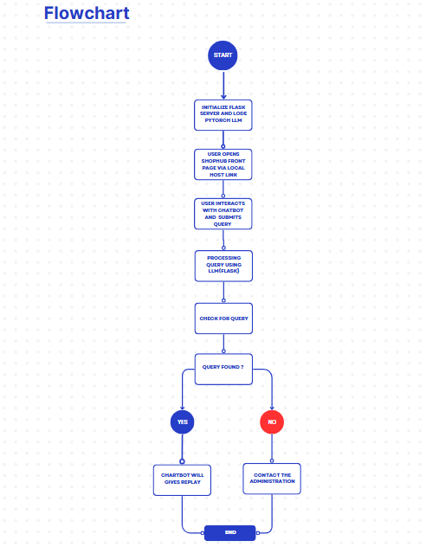

**Fig 1.1:Architecture of Chat-Bot**

# Architecture of Chatbot Figure 4.1 At a glance, figure 4.1 architecture reflects the flow of processes associated with processing a chat bot query, from which any query passes from one activity to the other; at the bottom are detailed elaborative steps as follows:

# 1. Customer Query or Request

# In this foundational step, the customer initiates interaction by posing a query or request to the chatbot in natural language. The input may include questions like "What is the status of my order?" or "I need help with my billing issue." These queries are typically aimed at gaining information, troubleshooting problems, or clearing doubts regarding products or services.

# Objective: Precisely capturing the user's input in a system-readable format.

# Importance: This should be the time when chatbots can successfully handle rich user inputs. Phrasal variations, spelling mistakes, slang usage, or incorrect sentence structures must not intervene with the recognition and processability of the query through the chatbot. System effectiveness ensures a smooth and hassle-free experience for a user, regardless of their phrasing variations.

# Step 2: Preparation of Response by Chatbot and Forwarding to ML-NLP Engine

# Once the user has entered his query, the chatbot's first job is to pre-process the input. This includes basic validation to ensure the clarity and completeness of the query. If ambiguous, the chatbot may request further clarification from the user to fine-tune the input.

# Goal: To pass the customer's query to the Machine Learning (ML) and Natural Language Processing (NLP) engine for deeper analysis.

# Activities:

# Validate the received query for compliance with the minimum threshold to be processed.

# Send the structured or raw user input to the ML-NLP engine for further processing.

# Result: The query is now ready for deep analysis, which enables the system to give a correct response based on the request of the user.

# Step 3: ML-NLP Engine

# The heart of the functionality for the chatbot. By leveraging ML and NLP, the engine is the one that takes in user input and gives it some meaning. There are two tasks performed in this stage:

# Intent Detection: This means the system determines the underlying intent or purpose behind a customer's question. Take the example of the question "Where is my order?"-its intent is labeled as "order status."

# Entity Extraction: NLP Engine extracts relevant entities or key information from the query like order ID, customer name, or date of billing. These extracted entities form critical inputs for further processing.

# Objective: To ensure that the chatbot understands the intention of the user and can identify what is needed to be delivered in the solution.

# Outcome: The system returns the identified intent and extracted entities to the chatbot, equipping it with the necessary information to address the query effectively.

# Step 4: Data Query Search Engine Interaction

# At this point, the chatbot uses the intent and entities extracted to retrieve relevant information from a backend database or data query engine. For instance, if the user's query is about an order status, the chatbot uses the order ID to query the database for details such as shipping status, tracking number, or estimated delivery date.

# Objective: Fetch dynamic, contextually relevant data that directly answers the user's request.

# Actions:

# Connect with the back-end systems such as order management and inventory database according to the intent and information drawn out.

# Accumulate and aggregate all data that would help build a coherent reply.

# Conclusion: The bot collects the desired information ready to display it in a friendlier manner.

# Step 5: Chatbot Replies to the Customer

# In the final step, the chatbot uses the information it has gathered to compose a comprehensive response to the user's query. For instance, if the question is about the status of an order, the answer would be: "Your order #12345 is being processed and will ship tomorrow."

# Goal: To provide a response that is correct, relevant, and in line with the customer's expectation.

# Actions:

# Present the information gathered in a natural language response.

# Additional support could include follow-up questions, reference to FAQs, and possible escalation to human support for issues that cannot be handled automatically.

# End: The user achieves satisfaction or next steps; an interaction cycle is complete

# .CHAPTER-5 OBJECTIVES

**5.1. Automate Customer Interactions**

The key goal of a customer support chatbot with machine learning is to automate customer interactions. This implies that the chatbot can autonomously handle a wide range of customer inquiries without requiring human intervention. The chatbot can recognize common queries about product details, order status, troubleshooting, or basic technical support and respond immediately with accurate answers.

By automating routine customer interactions, businesses can offer instant support around the clock, eliminating long wait times that customers often face when waiting for a human representative. The automation also reduces the reliance on customer support teams for common inquiries, enabling human agents to focus on more complex or personalized issues that require human expertise. This not only boosts the efficiency of customer support operations but also leads to consistent service delivery.

**5.2. Increase Response Accuracy**

Improving response accuracy is another crucial goal of integrating machine learning algorithms into customer support chatbots. ML allows chatbots to not only go beyond keyword matching but also to understand the intent behind a customer's query, even if the customer phrases the question differently. For instance, a customer might ask, "What is the status of my order?" or say, "Has my package shipped?" The chatbot can understand that both questions are the same intent: order tracking and give information accordingly.

As the chatbot learns from past interactions, it can continue to refine its understanding of user behavior, improving the relevance and accuracy of its responses. This leads to better customer satisfaction because customers receive more precise, context-aware answers to their questions. Reducing inaccurate or irrelevant responses also minimizes customer frustration, ultimately improving the chatbot’s reliability and trustworthiness.

**5.3. Enhance User Experience**

One of the most significant advantages of a machine learning-powered chatbot is that it can improve the overall user experience. Since the chatbot is available 24/7, customers can get help at any time, regardless of their location or time zone. Unlike human agents who work within specific hours, chatbots ensure that support is always available, catering to the needs of customers across the globe.

Besides, the chatbots give instantaneous replies, which minimize waiting times that customers usually encounter in contacting support. Response times help keep customers engaged and prevent frustration, therefore leading to increased loyalty. This is because the quick solutions or information given by chatbots promote a positive experience from customers, encouraging them to interact repeatedly and fostering loyalty towards the brand.

**5.4. Learn from Interactions**

One of the core objectives of machine learning-enabled chatbots is their ability to learn from customer interactions. The more conversations the chatbot handles, the more valuable data it collects to improve its performance with time. For example, it can analyze which types of questions customers frequently ask, what kind of responses lead to high satisfaction, and how customer preferences evolve.

This kind of learning process makes the chatbot more accurate, adaptable, and responsive to customer needs. The learning progresses so that the intent of customers and their preference grow over time, resulting in better responses from the chatbot. This makes sure the chatbot becomes responsive enough for new situations arising over time and changes happening within customers, making this bot even more valuable to a business.

**5.5. Scalability**

With increasing business volumes and the expanding customer bases, scalability in the machine learning-based chatbot can be quite critical. An ML-based chatbot, in this regard, scales up pretty well since one can manage more and more customer interactions without any alterations to the infrastructure. For instance, a small business might get few inquiries per day, but with a product launch or a seasonal promotion, it might explode in volume. A conventional support team will not keep up with such a scale, but the chatbot could easily handle thousands of conversations all at once.

Scalability helps ensure that the chatbot continues to be effective, even as customer expectations continue to grow and business needs change. The chatbot can be adapted and trained to respond to new forms of questions as the business expands into new areas of products or geographic locations. Thus, scalability ensures that user interaction volume increases and yet the quality of user support remains high as the business grows.

**5.6. User Feedback Loop**

Another significant input has to be the integration of the user feedback loop into an endless improvement process in enhancing capabilities. By taking initiatives, businesses can actually acquire insightful data with the customer experience during an interaction about where the chatbot lacks and can improve from here based on ratings, direct customers or satisfaction surveys.

The feedback loop allows the chatbot to self-improve by incorporating user suggestions and pain points. It also allows businesses to fine-tune responses to make them more in line with customer expectations. By continuously iterating on user feedback, the chatbot can evolve, improving its performance and ensuring that it meets the changing demands of customers.

# CHAPTER-6 SYSTEM DESIGN & IMPLEMENTATION

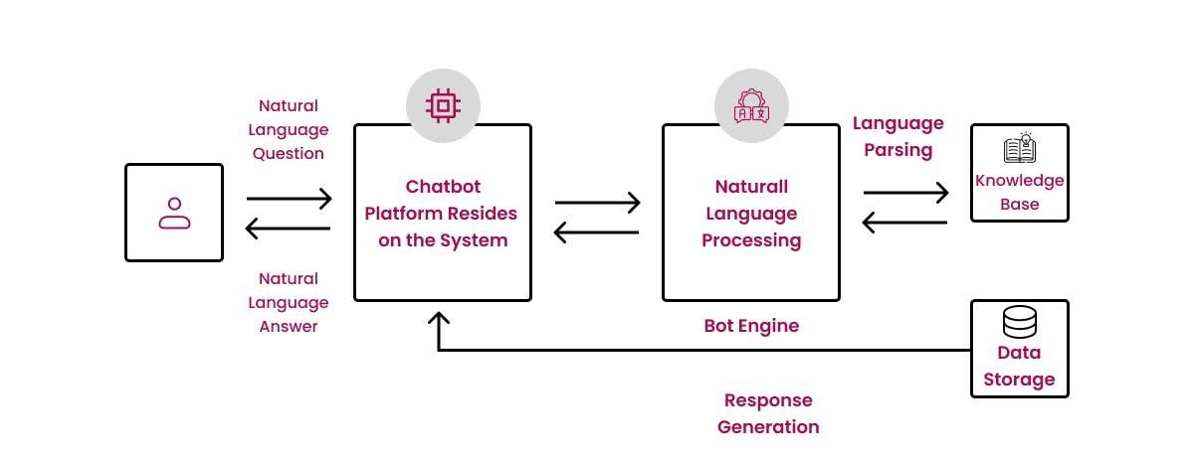

**Fig 1.2:Chatbot System Design**

**The Proposed method consists of the following steps:**

* Step-1: Customer Query/Request: Customer types the phrase in the chatbot.
* Step-2: Chatbot: It packs the data and responds to the customer and the phrase sent to ML-NLP engine (ML-NLP).
* Step-3: Machine Learning NLP engine (ML-NLP): Extracted user intent and entities sent back to chat-bot.
* Step-4: Data Query Search Engine: Chat-bot based on intent call upon services using entity information to find data from database. And data is returned to the

Chat-bot

# CHAPTER-7

**TIMELINE FOR EXECUTION OF PROJECT**

**10-01-2025**

**23-12-2024**

Figure 1.3 Timeline For Execution of Project

# CHAPTER-8 OUTCOMES

The integration of a Machine Learning (ML) powered Customer Support Chatbot yields significant improvements for both businesses and customers, fostering dynamic, efficient, and intelligent customer service solutions. ML chatbots enhance the way businesses interact with their customers, offering timely, accurate, and personalized responses, all while optimizing internal processes. Below are key outcomes that stem from the deployment of machine learning-based chatbots within customer support systems.

**8.1. Enhanced Customer Satisfaction**

Most influential effects in using ML-based chatbots would be customer satisfaction. With regards to today's customers, they expect prompt, personalized, and seamless service, which an ML chatbot would achieve through ensuring that the response was quick and tailored to their needs.

Real-Time Response: ML chatbots process customer queries in real-time and respond to them immediately. This eliminates the delay seen with traditional customer support methods and helps provide fast service to customers in today's fast-paced environment.

Context-Aware Accuracy: Machine learning enables the chatbots to understand fully what the customer is asking as well as the intent beneath, beyond just keyword recognition, so that the answers are more accurate and relevant. This improves customer issue resolution quickly, minimizing frustration from irrelevant and/or incorrect responses.

This, coupled with the fact that such an ML-powered chatbot could run 24/7 like a machine, whereas humans do not, would make a more favorable agent around-the-clock because customers can reach it for support at any given time. This is very crucial for businesses with international clientele or customers who work from different time zones.

By delivering on these features, customers feel that their needs are being met promptly and with precision, which in turn elevates satisfaction. When customers are happy with the support they receive, they are more likely to remain loyal to the brand, promoting customer retention and fostering positive word-of-mouth, which strengthens the overall reputation of the business.

**8.2. Increased Operational Efficiency**

The deployment of machine learning in customer support chatbots also drives operational improvements by making the most of resource allocation and cost reduction, thereby ensuring that businesses streamline their support systems.

Automation of routine queries: The ML chatbot can efficiently manage repetitive queries that include questions regarding the order status, product details, and account inquiries. By automating these routine tasks, businesses can reduce the involvement of human agents in dealing with these issues, thus freeing them up for more complex problems that require human empathy and judgment.

Cost Efficiency: Through automation, it will significantly bring down the cost of running any business. The use of chatbots in managing routine queries will reduce the size of customer support teams and the cost that comes with hiring and training large support staff. With ML chatbots, it is possible to scale the customer support operations without corresponding increases in staffing.

Rapid Issue Resolution: The chatbots can understand queries immediately and process them without delays, leading to faster resolution of issues. This reduction in average handling time (AHT) improves the speed of support and also increases overall throughput, thereby making the support process more efficient.

Essentially, ML-powered chatbots help businesses optimize support workflows, maximize resource utilization, and generally speed up and reduce the cost of customer service operations.

**8.3. Improved Customer Retention and Loyalty**

One less obvious but just as vital outcome of the use of ML chatbots is strengthening customer retention and loyalty. Consistent, personalized, and responsive service fosters long-term relationships with customers.

Personalized Experiences: Machine learning enables chatbots to learn from each customer interaction, allowing them to tailor responses based on the customer's past behavior or preferences. This personalization creates a sense of familiarity and trust, which enhances the customer's overall experience.

Proactive Support: ML chatbots will foresee what customers may need by looking at the pattern of previous interactions. For example, if a customer constantly asks for a specific product, the chatbot will be proactive in suggesting the right things to the customer so that he or she finds the solutions even before asking for them. Thus, proactive customer support improves user experience and enhances customer satisfaction.

Cross-Channel Support: All of these ML chatbots deliver the same, fast responses and ensure consistency across multiple websites, mobile apps, and all the other social media platforms. Thus, customers will always encounter the same high-quality service no matter where they might engage with the brand - greater customer loyalty is thereby created.

With ML-powered chatbots, one is able to develop a sense of customer loyalty by offering personalized and proactive support systems that help reduce churn and drive long-term retention.

**8.4. Scalability and Adaptability**

The major advantage of ML chatbots is their scalability. This is particularly true for businesses that expand and where customer demand grows. Scaling these chatbots seamlessly allows businesses to deal with volumes of customer inquiries without necessarily compromising service quality.

Manage the Increased Volume With peak seasons or specific promotions, the number of customer queries rises dramatically. Unlike human representatives, an ML-powered chatbot can process thousands of interactions in a given period, ensuring no customer waits for support to be served. This gives businesses a high level of service when demand is heightened, not frustrating customers because of waiting time or services bottlenecks.

Adaptability to Evolving Needs: ML chatbots are very adaptable, able to change with the evolving needs of businesses. As businesses expand their product offerings, enter new markets, or change their service models, chatbots can be retrained to address new types of inquiries. This makes the chatbot adapt to the growth and diversification strategies of the company.

Consistent Quality Service: One of the things businesses may find challenging when they start to scale is keeping high service quality. However, through ML-powered chatbots, this quality of service can remain uniform, irrespective of how many interactions there are. Therefore, the customers can expect the same level of support at all times and whatever the number of queries in processing.

The scalability and adaptability of the ML-powered chatbot ensure businesses can grow with such high quality customer support service regardless of how large their customers' number may be.

**8.5. Data-Driven Insights and Continuous Improvement**

A salient outcome from the employment of an ML-based chatbot is its ability to generate a ton of data from customer engagements. Through analysis, a company gains valuable insights into customer behavior, can identify common pain points and continuously improve the chatbot performance.

Identifying Trends and Patterns: ML chatbots collect data with each customer interaction, which facilitates businesses to find recurring queries or frequent problems. The outcome of such data can contribute to knowledge base improvement, optimization in chatbot responses, and even enhancements in products or services. It can help businesses make intelligent decisions by understanding the patterns for customer behavior that will directly influence their ability to modify the customer experience.

Real-time performance analytics: With the machine learning models, chatbots' performance can be monitored in real time. Response accuracy, customer satisfaction, and query resolution time can be calculated with this model. These insights from performance help businesses gauge how effective their chatbots are and where they can be improved.

Continuous Learning and Self-Improvement: The most prominent feature of ML chatbots is that they learn and improve over time. The more they interact with customers, the better they understand different queries and adapt to meet the needs of customers. This process of iterative learning ensures that the chatbot becomes more competent in handling complex and nuanced interactions.

With data analytics and continuous learning, businesses can perfect their chatbots to ensure that the bot is always providing correct and relevant customer support efficiently.

# CHAPTER-9 RESULTS AND DISCUSSIONS

# The integration of Machine Learning (ML) into Customer Support Chatbots aims to enhance customer service by providing faster, more efficient, and personalized assistance. This section outlines the results of implementing a machine learningpowered chatbot in a customer support setting, followed by a discussion of the findings, challenges, and future directions.

# 9.1 RESULTS

# The implementation of Machine Learning (ML)-driven Customer Support Chatbots has been created to completely transform the functioning of customer service operations with improved velocity, personalization, and efficiency of support systems. In this chapter, the impact of implementing a machine learning chatbot into customer support environments is reviewed, findings discussed, and challenges noted, as well as opportunities for further advancements in the system.

# 9.1 Results

# 1. Improved Customer Query Handling

# The ML-based chatbot really made the process more efficient to handle customer questions. The system showed a highly developed ability to interpret a large range of customer queries, mainly those that revolved around frequently asked questions, tracking orders, accounts, and troubleshooting.

# Response Time: Before the implementation, the response time for customer queries was between 3 to 5 minutes when handled by human agents. After the deployment of the chatbot, the response time was reduced to less than one minute. This significant improvement ensured that customers received prompt assistance without any delay.

# Precision in Responses: By utilizing machine learning algorithms, especially Natural Language Processing (NLP), the chatbot exhibited an improved ability to interpret and process complex queries accurately. The bot understood the context and nuances of customer inquiries, allowing it to deliver more precise and relevant responses, which is a significant leap forward from traditional rule-based systems.

# 2. Boost in Operational Efficiency

# The ability of the ML-powered chatbot to support a high volume of the routine inquiries of customers allowed for significantly improved operational efficiencies. It included order-status queries, account issues, as well as common troubleshooting.

# Re-delegation and Optimization by Eliminating Human Intervention: Following the chatbot's immense success in handling 70-80% of every customer interaction, human employees' workload reduced, and thereby were freed to focus their efforts on more complex problems and matters. This significantly helped optimize the utilization of human resources while also effectively streamlining the entire workforce engaged in customer support work.

# Cost Savings: The automation of routine tasks visibly decreased the staffing and training operational costs. With lower needs for a large team in customer service, a lot of businesses saved a tremendous amount while keeping the services of great quality.

# 3. Customer Satisfaction

# Implementing the ML chatbot resulted in a positive outcome of higher customer satisfaction through continuous support.

# Better Satisfactory Rate: The feedback survey showed that about 85% of the customers were satisfied with their interaction with the chatbot. Users appreciated promptness in response and the flexibility of getting help at any time of day or night.

# Decreased Wait Times: One of the significant advantages of the chatbot was that it gave instant solutions or escalated a complex issue to human agents. It significantly reduced the wait time, which enhanced the overall customer experience and left customers feeling valued and heard.

# 4. Scalability and Load Management

# The ML-powered chatbot showed great scalability, especially during peak times. In promotional sales and other high-demand periods, the chatbot was able to take care of up to 40% more customer interactions without any degradation in service quality.

# Peak Load Handling: The chatbot handled the increased customer queries during the peak demand periods, for example, during sales events. It ensured that the system was responsive without overloading or requiring additional resources. This scalability allowed the business to handle high volumes of support requests without compromising on the quality of service.

# 5. Continuous Learning and Adaptation

# This helped the ML chatbot to learn on time and thus improve the ability over time.

# The ML chatbot was enhancing response quality due to adaptations for various interactions, as its performance kept on improving every day with diverse language usage patterns, cultural nuances, and customer preferences.

# Thereby, it was no only responding well to more complex queries but also the questions of different types than were it would ever answer them previously.

# 9.2 Discussion

# 1. Advantages of the Chatbot Implementation

# The deployment of the ML-powered chatbot resulted in a number of benefits, most of which were related to operational efficiency and customer satisfaction. Routine tasks became automated, which helped speed up query resolution and decreased the load on customer service agents. Moreover, advanced machine learning algorithms, such as NLP, helped the chatbot understand the nuances of customer language, making responses faster and more accurate than those from traditional systems.

# Moreover, the scalability of the chatbot towards handling peak customer demand on specific days was an excellent advantage. Scalability does ensure that the system and the business grow together and there is no compromise in delivering service quality while dealing with fluctuating demand. Business entities experiencing seasonal spikes may not be able to absorb the increased volume with its human agents.

# 2. Challenges Faced

# Despite the successes, the implementation of the ML-powered chatbot did encounter several challenges:

# Complexity of Queries: While the chatbot was highly effective for handling standard inquiries, it struggled with more complicated or ambiguous customer requests. Informal language, vague queries, or specific customer contexts sometimes led to misinterpretations or irrelevant responses. While the system learned from these experiences, ongoing updates and refinements were necessary to ensure it could handle a broader range of queries.

# Sentiment Analysis: The ability of the chatbot to detect and respond appropriately to customer emotions was weak. It identified some keywords that were relevant to negative sentiments but lacked emotional intelligence in order to feel the frustration or anger from customers. This brought the need for human intervention to be essential in more sensitive or complex interactions with the customers.

# System Integration: Integrating the chatbot with the existing customer support systems and backend databases presented challenges. It was very important that the chatbot retrieved and presented the correct information from the various systems. This necessitated careful configuration, extensive testing, and occasional troubleshooting to ensure seamless functionality

# 3. Future Directions and Improvements

# There are several opportunities to improve the functionality of the chatbot and its further capabilities:

# Advanced Sentiment Analysis: This will enhance the ability of the chatbot to handle more complex emotional interactions. It will have a better understanding of the emotions of the customer by including more sophisticated sentiment analysis tools. The chatbot would be able to offer empathetic responses and improve the customer experience in sensitive situations by detecting nuances such as frustration or anger.

# Context-Aware Conversations: Currently, it can handle individual queries but needs improvement in handling continued, context-aware conversations. It can remember past interactions with customers and offer more personalized service and anticipate future needs, making the experience seamless and customer-centric.

# Hybrid Human-Chatbot Collaboration: This can be particularly useful when very difficult cases require being escalated from the chatbot to a human agent in a way that the handover from the chatbot is smooth, with the information available to the human agent from the chatbot in order to avoid the need for the customer to restate.

# Multilingual Capabilities: As businesses expand into new markets, the chatbot’s ability to support multiple languages would be invaluable. By accommodating customers in their preferred language, the chatbot could serve a global audience, ensuring that businesses can offer effective support to international customers.

# CHAPTER-10 CONCLUSION

# There are numerous benefits to the development of customer support chatbots that are based on ML and NLP, programmed in Python, as opposed to traditional rule-based solutions. With the aid of ML, these chatbots can learn and improve with time, incorporating the insights garnered from every user interaction and feedback. That gives a very impressive nature to the chatbot as it can handle such a vast range of inquiries with increased accuracy, not to mention even when posed ambiguously, using slangs, or less used phrases. Therefore, diverse customer needs are better taken care of, making the chatbot an invaluable asset for the support system.

# NLP techniques are significantly responsible for the effectiveness of interpretation and comprehension by the chatbot in regard to customers' intent. Unlike scripts-dependent traditional systems, NLP allows the chatbot not only to recognize the keyword but to understand what's going on in the conversation as a whole. This would lead the chatbot into much more meaningful, dynamic, and personalized dialogues with users. Consequently, the chatbot can offer more accurate, contextually relevant responses, which elevates the overall customer experience, leading to higher satisfaction levels and fostering greater brand loyalty. Customers feel valued when their inquiries are handled swiftly and correctly, contributing to a positive and lasting relationship with the brand.

# The tangible business benefits of a self-learning, ML-powered chatbot include reduced operational costs. This is one of the most significant advantages of using a chatbot. Chatbots can work 24/7, constantly engaging and supporting customers even when no human staff is available. This way, customers can access help at their convenience, whether it's in the middle of the night or during holidays. Additionally, the chatbot can effectively manage a large number of interactions at the same time without human intervention, enabling businesses to scale up customer support operations without proportional staff increases. The capacity for handling large-scale support demands ensures that customer service levels remain consistent, even during peak periods, such as product launches or promotional events.

# These efficiencies free human customer service agents from the burden of addressing routine or repetitive tasks. They are thus able to concentrate their expertise on much more complex and specialized problems that demand human judgment and problem-solving. This benefits the support team's productivity in general, while businesses can efficiently use resources to prioritize intricate customer concerns and leave the routine questions to be sorted out by the chatbot.

# In conclusion, the adoption of machine learning and natural language in customer support chatbots offers the potential to revolutionarily change the way businesses approach their customers. Such advance systems not only enhance an organization's operational efficiency but also provide a more prompt, personalized, and empathetic understanding of the customer. Advanced machine learning and natural language understanding technologies will continue changing the nature of future, more intuitive, capable, and even indispensable chatbots in customer support. They will meet not only the changing expectations of customers but also, to some extent, be ahead of customers' expectations. Thus, it will become an always-smooth and efficient ecosystem for customer service. Over time, these chatbots will certainly define the future of customer service, establishing new paradigms for interaction, engagement, and satisfaction.

# REFERENCES

1. R. Madana Mohana, Bharat institute of Engineering and Technology,

Hyderabad, Telangana and N. Pity, Indian Institute of Science, Bangalore,

India. Advances in intelligent Systems and Computing(2020)-

Customer

Support Chatbot Using Machine Learning.

https://www.researchgate.net/publication/343980800_Customer_Support_Ch at bot_Using_Machine_Learning

1. K. Jwala, G.N.V.G Sirisha, G.V. Padma Raju, International Journal of

Recent Technology and Engineering (IJRTE) ISSN: 2277-3878, Volume-8 Issue-1S3, June 2019, developing a Chatbot using Machine Learning https://www.ijrte.org/wpcontent/uploads/papers/v8i1S3/A10170681S319.pdf

1. A step-by-step guide to pdf chatbots with ML and Ollama, Jul-2024 https://www.analyticsvidhya.com/blog/2023/10/a-step-by-step-guide-to pdfchatbots-with-langchain-and-ollama/
2. Binny Vyas (November 9, 2017). 6 key metrics to measure the performance of your chatbot. Retrieved from https://chatbotslife.com/
3. Sasa Arsovski, Imagineering Institute and City, University of London and

Idris Muniru, Universiti Teknologi Malaysia: Analysis of the Chatbot Open Source Languages a AIML and Chatscript: A Review, February 2017. naveen_capstone(finalReport).docxhttps://www.researchgate.net/publication/323279398_ANALYSIS_OF_T

HE_CHATBOT_OPEN_SOURCE_LANGUAGES_AIML_AND_CHATS

CRIPT_A_Review

1. Will Gannon: An Interactive History of Chatbots, 21 Jul, 2017. http://blog.aylien.com/interactive-history-chatbots/
2. Pavel Surmenok: Chatbot Architecture, Sep 11, 2016.

https://medium.com/@surmenok/chatbot-architecture-496f5bf820ed

# APPENDIX-A PSUEDOCODE

# def start_flask_application():

# initialize_flask_server()

# load_pytorch_model()

# load_query_response_database()

# hosting_url = get_flask_hosting_url() // Example: http://127.0.0.1:5000

# return hosting_url

# def open_in_browser(hosting_url):

# browser.open(hosting_url)

# def show_homepage():

# display_webpage_ui()

# add_chatbot_ui(position=”bottom-right”, sticky=True)

# def launch_chatbot():

# user_clicks_chatbot_icon()

# return wait_for_user_input()

# def get_user_query():

# query = get_input_from_chatbot_ui()

# return query

# def process_query(query):

# sanitized_query = sanitize_query(query)

# detected_intent = detect_intent_pytorch(sanitized_query)

# return detected_intent

# def search_query_in_database(query):

# if database_contains_query(query):

# answer = get_answer_from_database(query)

# return answer

# else:

# report_unanswered_request(query)

# return “Contact Administration”

# def generate_response(query):

# detected_intent = process_query(query)

# answer = search_query_in_database(query)

# return answer

# def respond_to_user(answer):

# send_answer_to_chatbot_ui(answer)

# def close_chatbot():

# def keep_ if (user_close_chatbot() or user leave message): end chat session

# server_active():

# while True:

# wait_next_request()

# def main():

# hosting_url = start_flask_application()

# open_in_browser(hosting_url)

# show_homepage()

# While the options are available forever, earlier I had the view counter.

# query = get_user_query()

# response = generate_response(query)

# respond_to_user(response)

# if user_wants_to_exit8143():

# close_chatbot()

# break

# While true:

# main()

# keep_server_active()

**APPENDIX-A.1**

**Algorithm**

#include <stdio.h>

#include <string.h>

1.Start

Scroll through the items

Add to cart

Buy

Step 2: Display the Homepage

if(chatbot is activated)

{

launch chatbot;

}

Step 3: Handle User Input

Ask the user for their choice

Read the user's input (choice).

Step 4: Chatbot Interaction

1.If the user selects Option 1:

Launch the chatbot.

Print: "Chatbot Launched.

2.Prompt the user to enter a question:

Print: "Enter your question:"

Read the user's input (query).

3.Initialize a variable found to 0 to track if the query exists in the database.

Step 5: Query the Database

1.Search for the user's query in the database:

Loop through the database (db) using a for loop.

If a match is found (strcmp(db[i].question, query) == 0)

Set found to 1.

Display the chatbot's response (db[i].response).

Break out of the loop.

2.If the query is not found (found == 0):

Print: "Chatbot Response: Contact Administration."

Add the unanswered query to the database:

Copy the query into db[db_size].question.

Set the response for this query as "Pending further investigation."

Increment db_size to reflect the new entry.

Print: "Unanswered query added to the database."

step 6:Loop

1.If a match is found (strcmp(db[i].question, query) == 0):

Set found to 1.

Display the chatbot's response (db[i].response).

Break out of the loop.

2.If the query is not found (found == 0):

Print: "Chatbot Response: Contact Administration."

Add the unanswered query to the database:

Copy the query into db[db_size].question.

Set the response for this query as "Pending further investigation."

Increment db_size to reflect the new entry.

Print: "Unanswered query added to the database."

Step 7: Close Chatbot or Exit Program

1.If the user selects Option 2:

Print: "Chatbot Closed. Exiting Program..."

Set running to 0 to exit the loop.

step 8: If the user provides an invalid input:

Print: "Invalid Choice. Please try again."

step 9:Exit the loop

Print: "Server Shut Down."

step 10: close the chatbot

else{

continue shopping;

}

END

# APPENDIX-B SCREENSHOTS

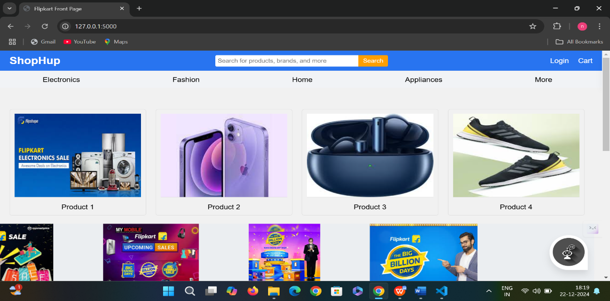

**Fig 1.4 Display the home page**

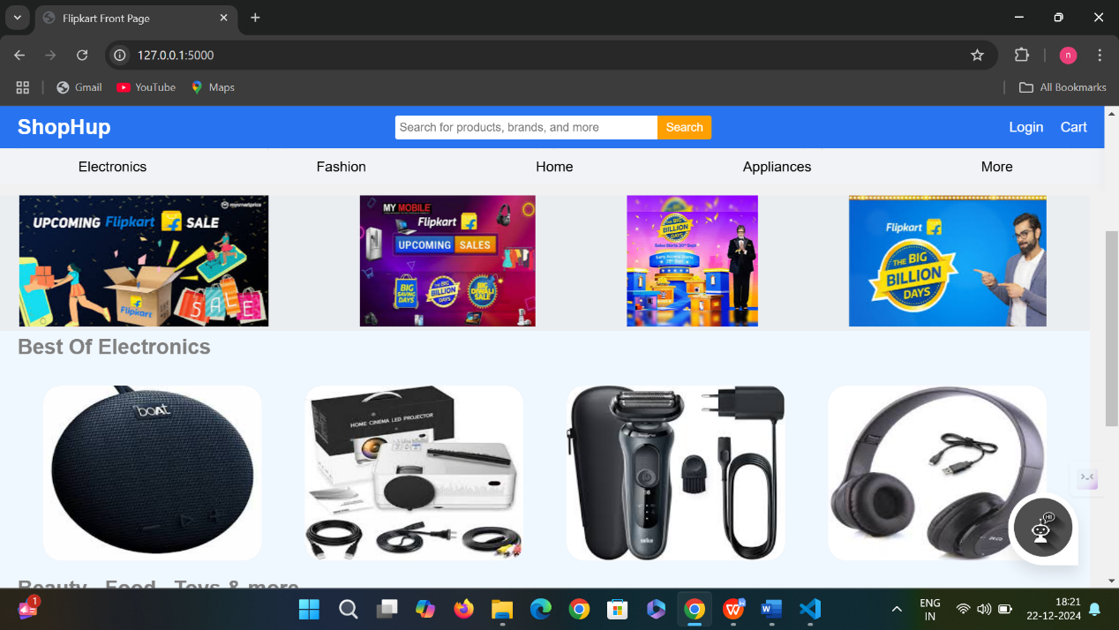

**Fig 1.5 Display the products**

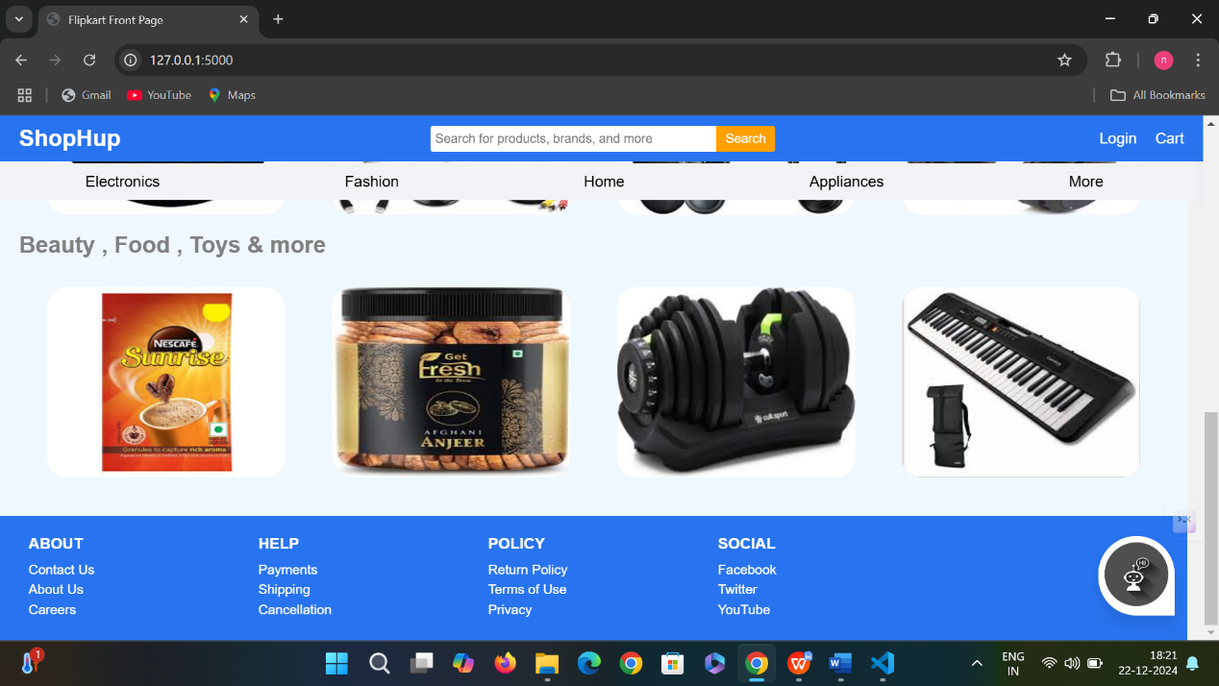

**Fig 1.6 Display the home page footer**

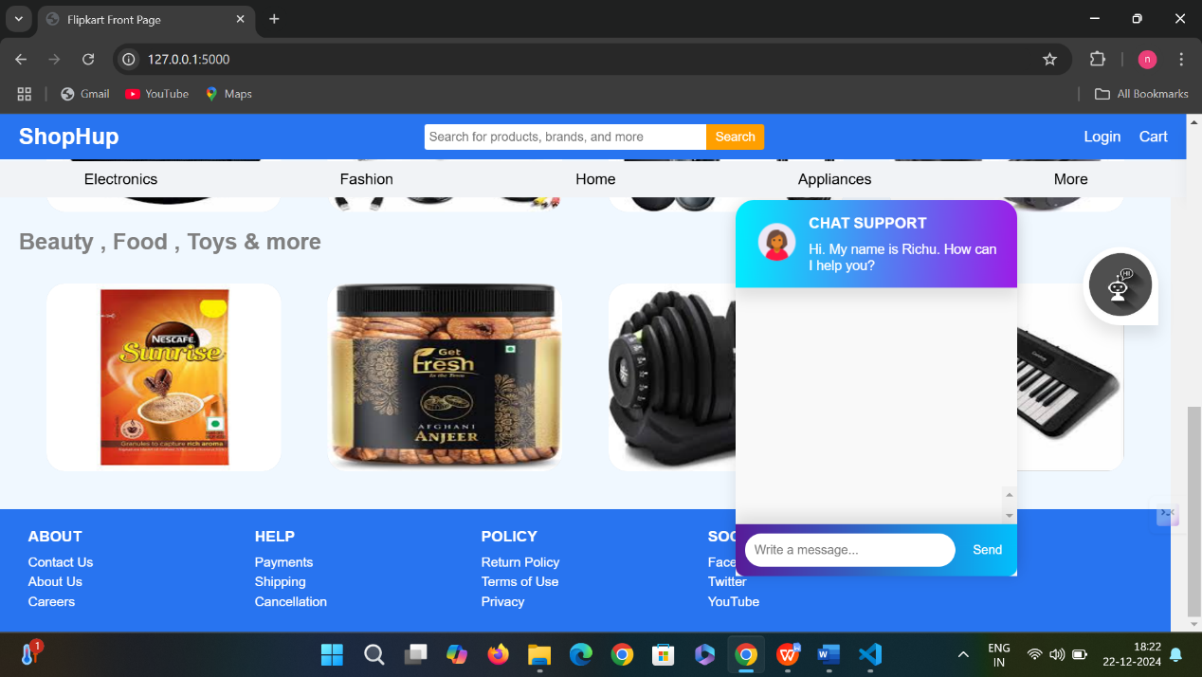

**Fig 1.7 Chatbot UI**

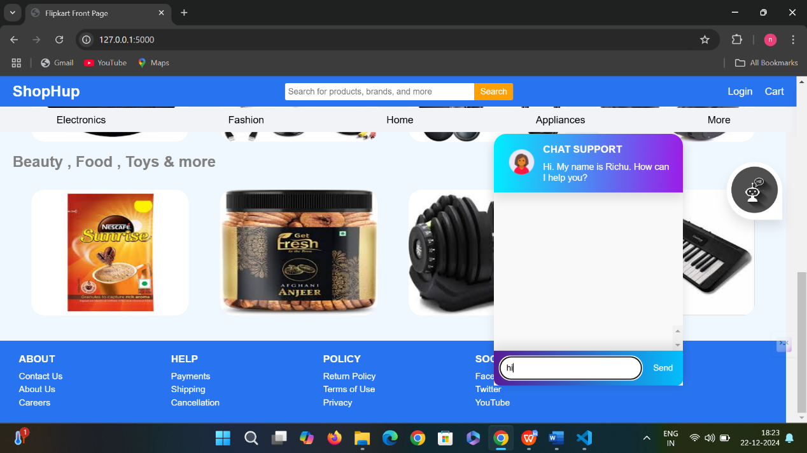

**Fig 1.8 Start a conversation with chatbot**

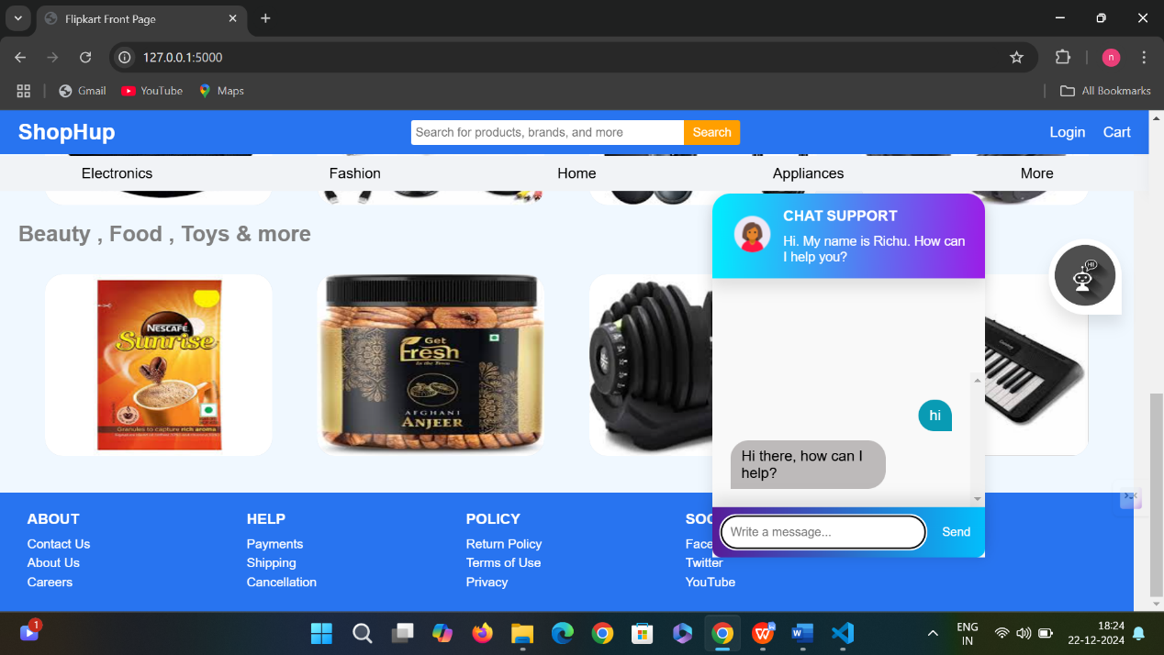

**Fig 1.9 Chatbot response from the server side**

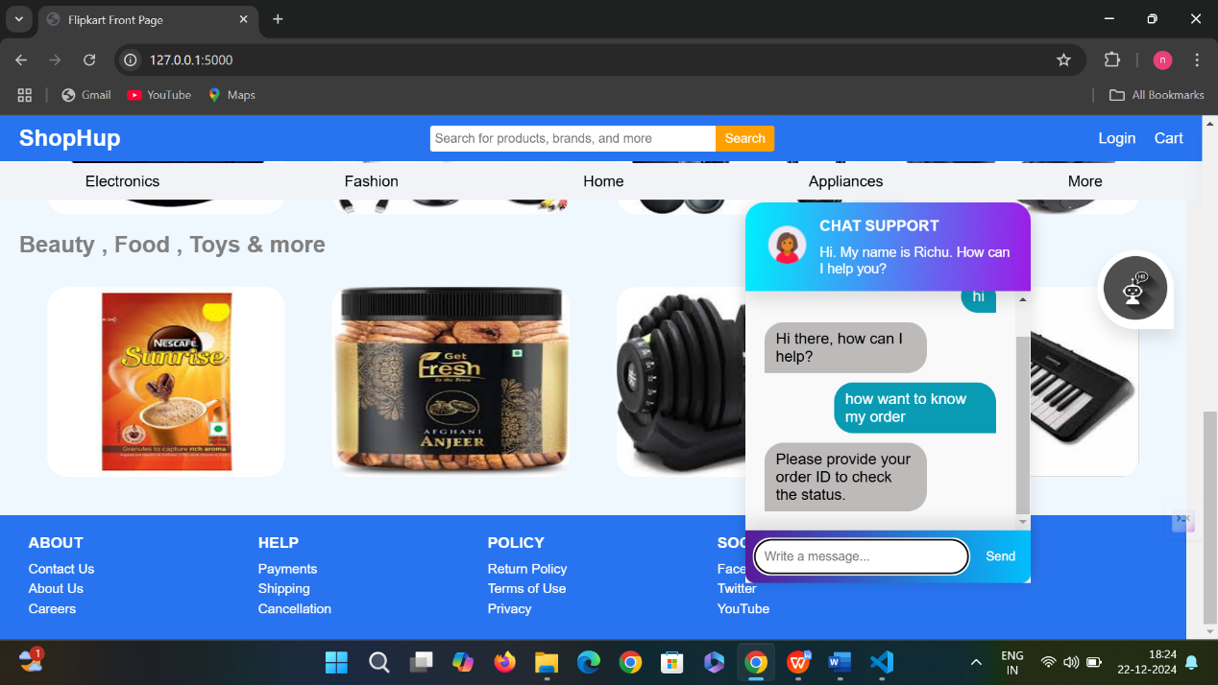

**Fig 2.0 Query 1**

**Asking information about my order**

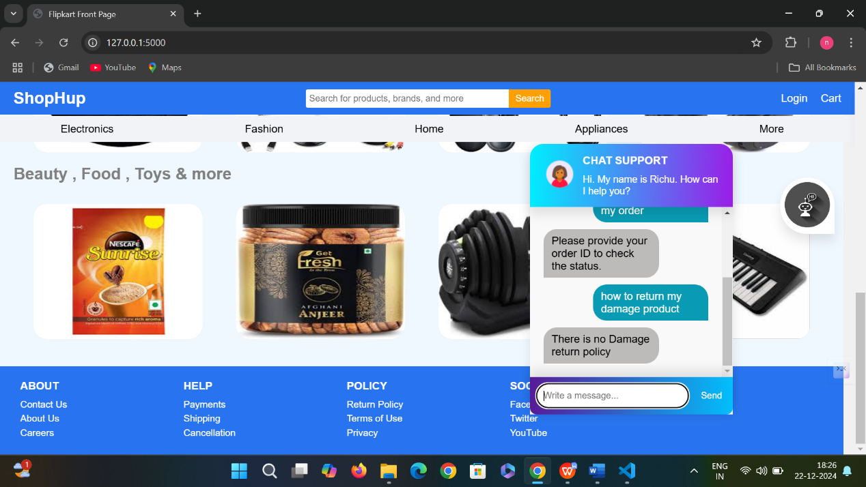

**Fig 2.1 Query 2**

**Asking the query about product condition**

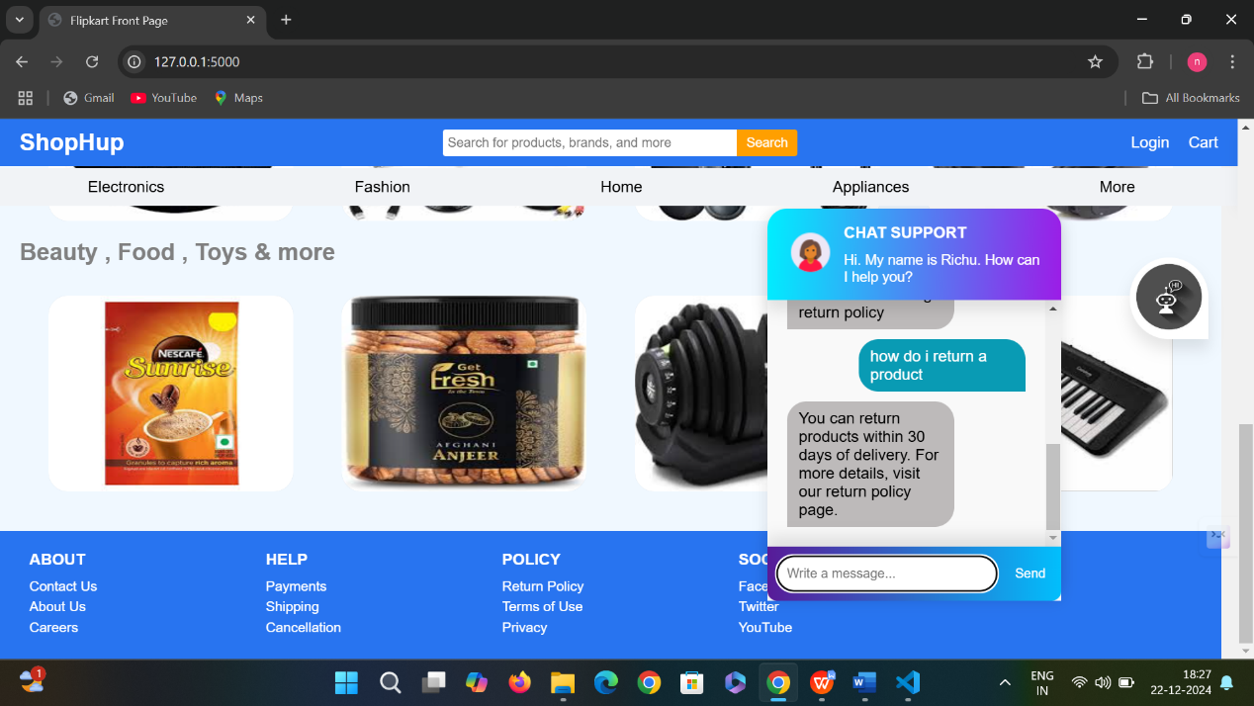

**Fig 2.2 Query 3**

**Asking information about return policy**

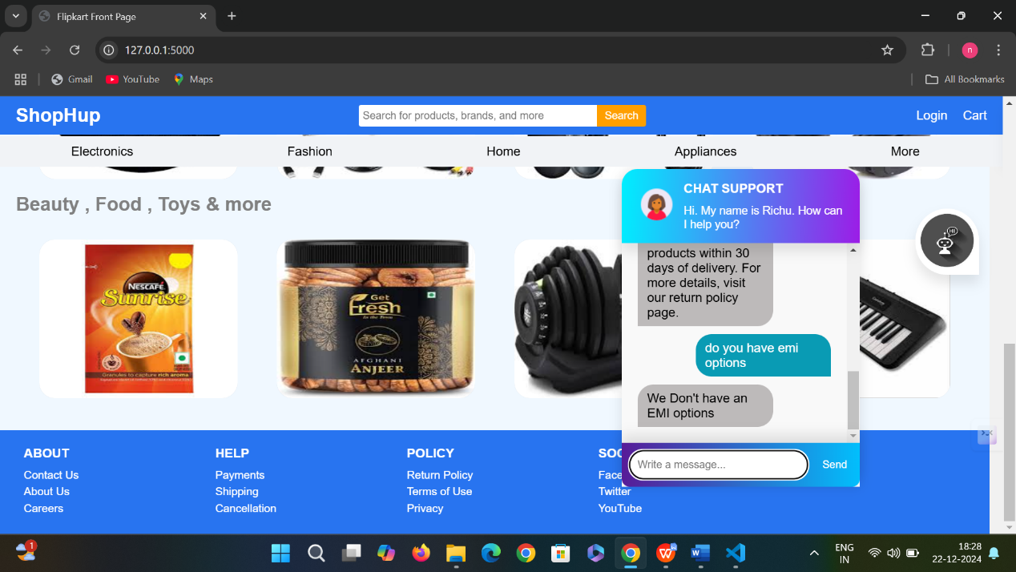

**Fig 2.3 Query 4**

**Asking information about payment methods and EMI options**

**APPENDIX-C**

**ENCLOSURES**

1. **Journal publication/Conference Paper Presented Certificates of all students.**
2. **Include certificate(s) of any Achievement/Award won in any project-related event.**
3. **Similarity Index / Plagiarism Check report clearly showing the Percentage (%). No need for a page-wise explanation.**
4. **Details of mapping the project with the Sustainable Development Goals (SDGs).**

**Project work mapping with SDG**



Fig 2.4 Alignment of the Project with SDG 3 - Good Health and Well-Being

This figure illustrates how the project contributes to the attainment of the Sustainable Development Goals, specifically SDG 3, through improved health outcomes.

The Project work carried out here is mapped to SDG-9

**INDUSTRY, INNOVATION AND INFRASTRUCTURE:**

This innovation project promotes innovation through applying machine learning to improve the service to customers. The project supports building resilient infrastructure through digital technologies and improves efficient communication between businesses and their customers. It integrates intelligent automation to modernize industries and make them more responsive to user needs, paving the way for sustainable industrial growth.